Journal of Global Cancer Research

About the Journal:
The Journal of Global Cancer Research is a peer-reviewed publication dedicated to advancing the understanding, diagnosis, and treatment of cancer worldwide. We publish original research articles, clinical studies, case reports, and reviews spanning the full spectrum of oncology — from molecular and cellular mechanisms of cancer biology to translational research and cutting-edge clinical advancements. Our goal is to provide a trusted platform where researchers, clinicians, and healthcare professionals can share findings that meaningfully impact patient outcomes and shape the future of cancer care.
Bringing together contributors from across the globe, the journal fosters collaboration among oncologists, researchers, and public health experts committed to reducing the global burden of cancer. We prioritize rigorous peer review, scientific integrity, and open dialogue on emerging therapies, diagnostic innovations, and multidisciplinary approaches to treatment. Whether you are a clinician seeking the latest evidence-based practices or a researcher advancing novel therapeutic strategies, the Journal of Global Cancer Research aims to be an essential resource in the ongoing fight against cancer.
Latest News:
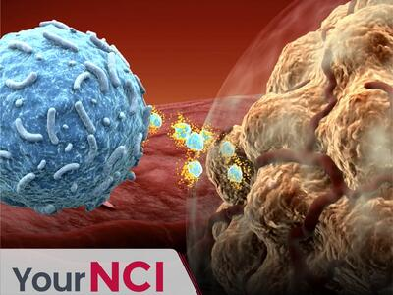
How Decades of NCI Support Led to Groundbreaking Discoveries: The Story of Immune Checkpoint Inhibitors
Immune checkpoint inhibitors have revolutionized cancer treatment, helping people with advanced melanoma, lung cancer, bladder cancer, and other cancers live longer, healthier lives. This is the story of how decades of NCI-funded research made these breakthrough immunotherapy drugs possible.
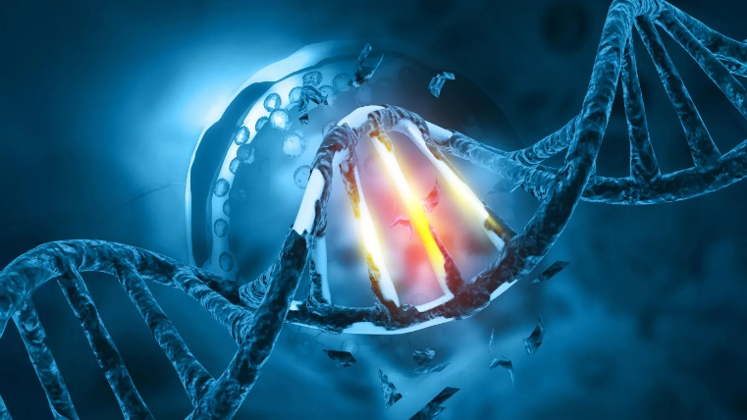
Why the Same DNA Damage Causes Cancer in Some People but Not Others
A controlled mouse study has provided direct evidence that inherited genetics can steer how cancer begins and evolves after DNA damage. The discovery could eventually help doctors better predict cancer risk and tailor screening and treatments to each patient.

CRISPR makes prostate cancer vulnerable to immunotherapy
Scientists used CRISPR to make prostate cancer cells easier for the immune system to detect and destroy. The experimental treatment dramatically improved the effects of immunotherapy in mice and may offer hope for other hard-to-treat tumors.
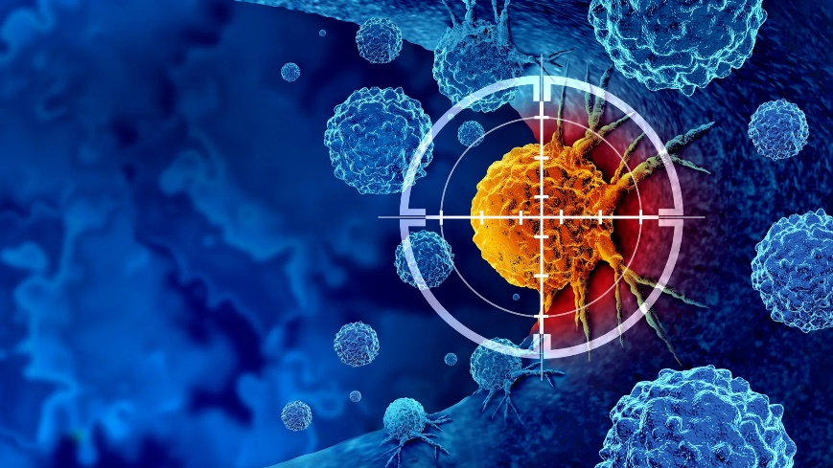

New cancer strategy could stop tumors before resistance takes hold
Researchers are applying evolutionary theory to cancer by changing treatments before tumors have time to develop resistance. Mathematical models suggest that rapid, carefully timed switches between multiple therapies could improve cure rates.
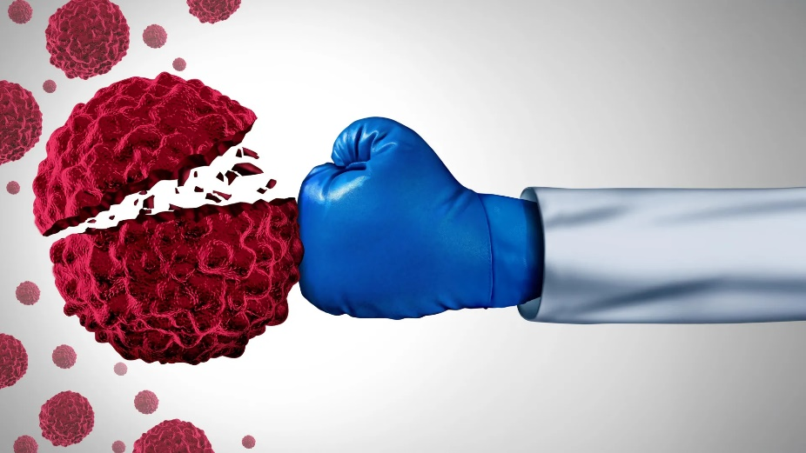

Scientific Topics:

1. Molecular Oncology and Cancer Biology
Exploring the genetic and molecular mechanisms driving tumor initiation, progression, and metastasis.
Advancing foundational research that underpins targeted cancer therapies.
2. Clinical Oncology and Cancer Therapeutics
Highlighting advances in chemotherapy, targeted therapy, and combination treatment protocols.
Bridging bench research with real-world clinical practice and patient outcomes.
3. Cancer Immunotherapy
Advancing the frontiers of immune-based cancer treatments through rigorous, peer-reviewed research.
Covering checkpoint inhibitors, CAR-T therapy, and emerging immuno-oncology breakthroughs.
4. Radiation Oncology
Examining innovations in radiotherapy techniques, precision targeting, and treatment planning.
Improving efficacy while minimizing damage to surrounding healthy tissue.
5. Surgical Oncology
Showcasing advancements in surgical techniques, minimally invasive procedures, and post-operative care.
Focused on improving survival rates and quality of life for cancer patients.
6. Pediatric Oncology
Advancing the frontiers of childhood cancer through rigorous, peer-reviewed open-access research.
Addressing the unique biological and treatment challenges faced by young patients.
7. Breast Cancer Research
Dedicated to early detection, novel therapeutics, and personalized treatment strategies.
Covering epidemiology, screening advances, and survivorship research worldwide.
8. Gastrointestinal Cancers
Exploring research on colorectal, gastric, pancreatic, and liver cancers.
Focused on early diagnosis, novel treatments, and improved patient prognosis.
9. Cancer Epidemiology and Public Health
Investigating global cancer trends, risk factors, and prevention strategies.
Supporting evidence-based policy for cancer control and health equity.
10. Cancer Genomics and Precision Medicine
Advancing personalized treatment approaches based on genetic and molecular profiling.
Driving the shift toward individualized, biomarker-guided cancer care.
11. Palliative Care and Cancer Survivorship
Addressing quality-of-life, symptom management, and long-term care for cancer patients.
Supporting holistic approaches to survivorship beyond active treatment.
12. Cancer Diagnostics and Biomarkers
Highlighting advances in early detection technologies, imaging, and diagnostic biomarkers.
Enabling earlier intervention and more accurate prognosis across cancer types.
Editorial in Chief:
Yifan Li
Shanxi Provincial Cancer Hospital, China

Biography:
Dr. Li is a surgeon and researcher at Shanxi Provincial Cancer Hospital, specializing in the management of gastric cancer. He is dedicated to improving patient prognosis and quality of life through clinical and research excellence. His work focuses on prognostic modeling and precision oncology, intending to translate research findings into improved therapeutic strategies for gastric cancer patients.
6 Articles are attached….

